**Connecting to MongoDB.**

>npm install monodb

const MongoClient = require('mongodb').MongoClient;

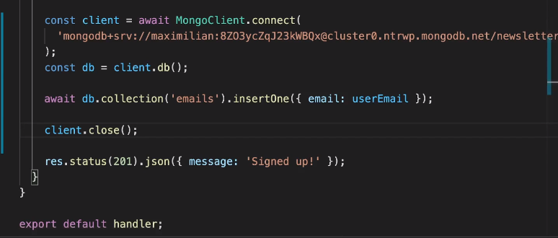

Here we can give mongoDB Key , because it is not rendered to client.

For all operations check monogdb npm documentation